

**MOOR TIME SOCIAL STORY**

**Days at the scout hut in**

**Ben Rhydding (not trips)**

Please share this social story with your young person to help them prepare for holiday club days at the Scout and Guide HQ in Ben Rhydding. Please refer to other social stories for trip days off site.

**I am going to holiday club.**

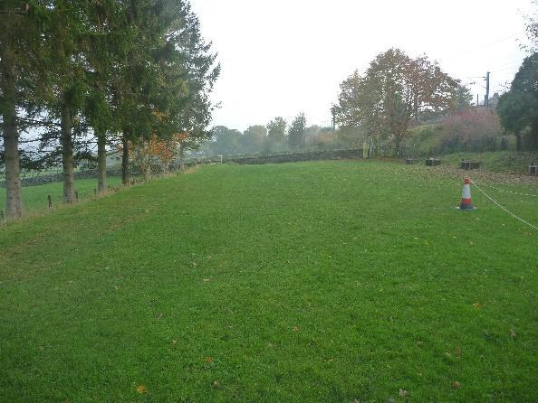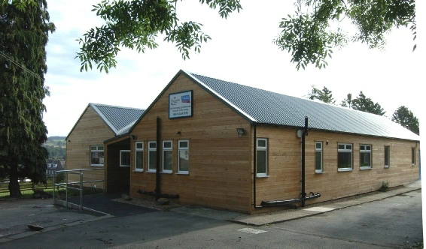

**I will do lots of fun activities. I can choose what I would like to do. I will have lots of fun.**

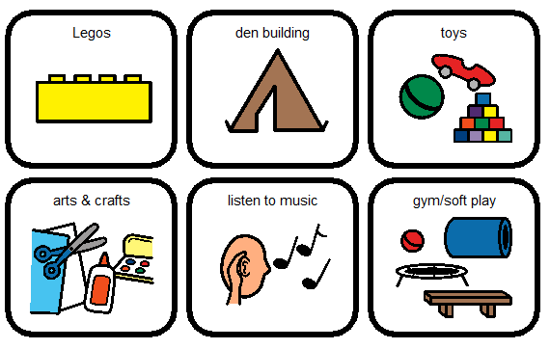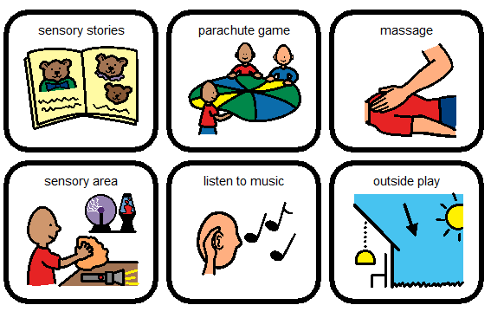

**There is always an adult at Moor Time to help me if I am worried, or if I need some extra help. The adults are kind, and like to join in with all the fun activities.**

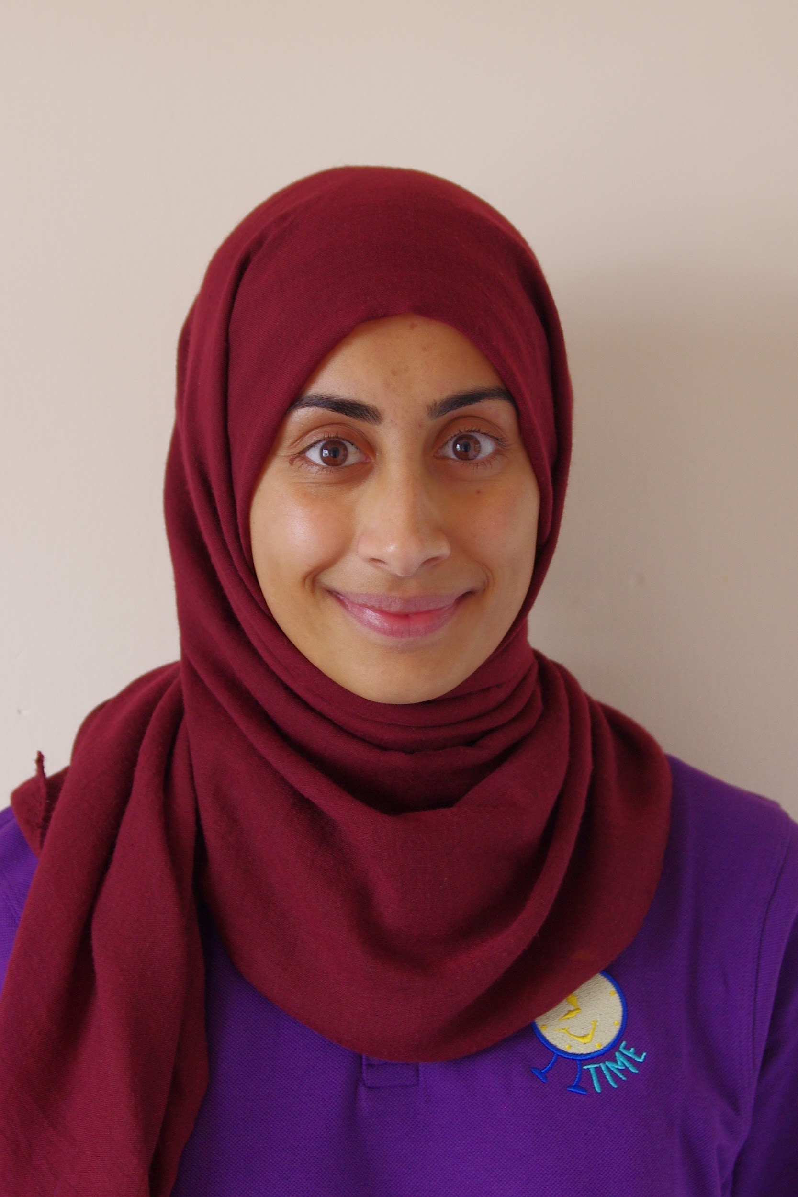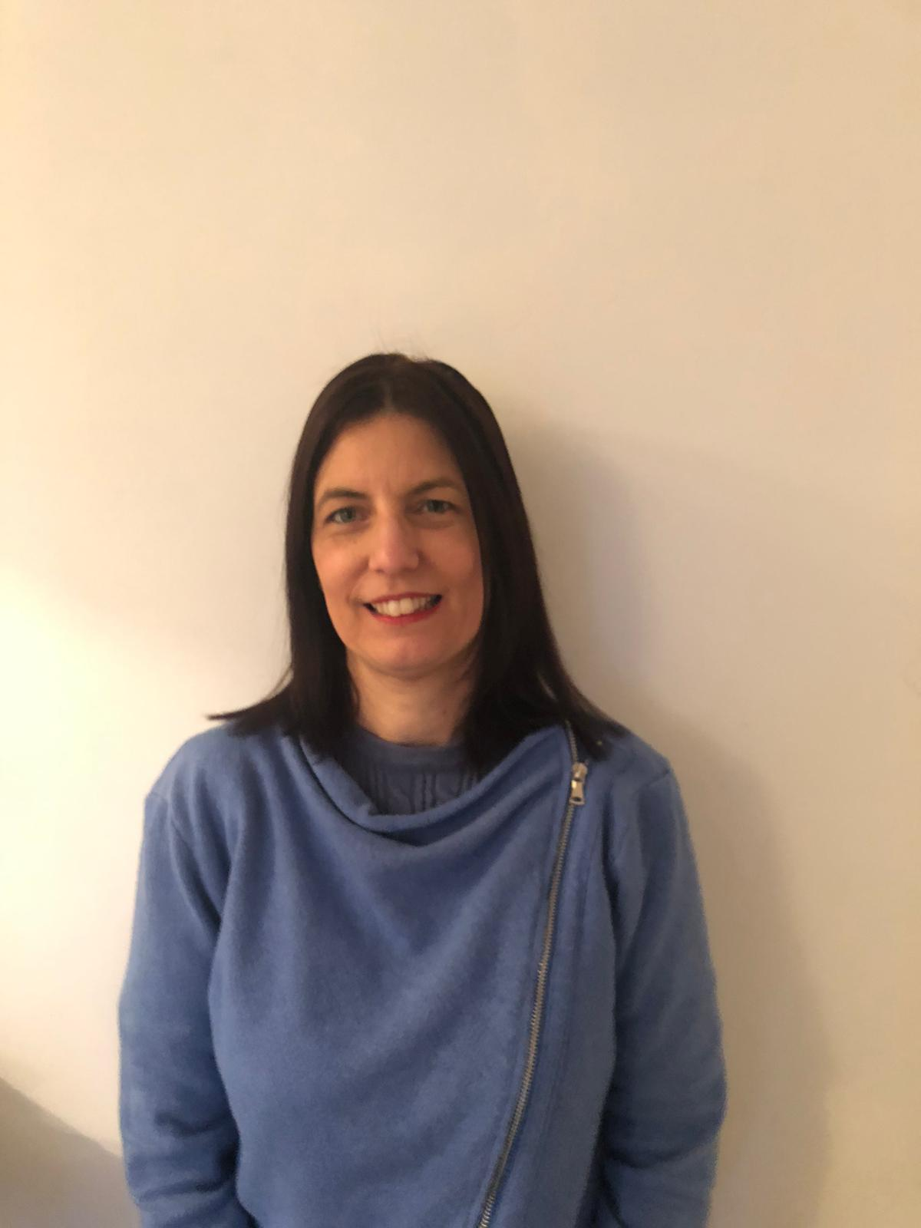

**I will have my dinner and snack at the holiday club. I can also bring my own 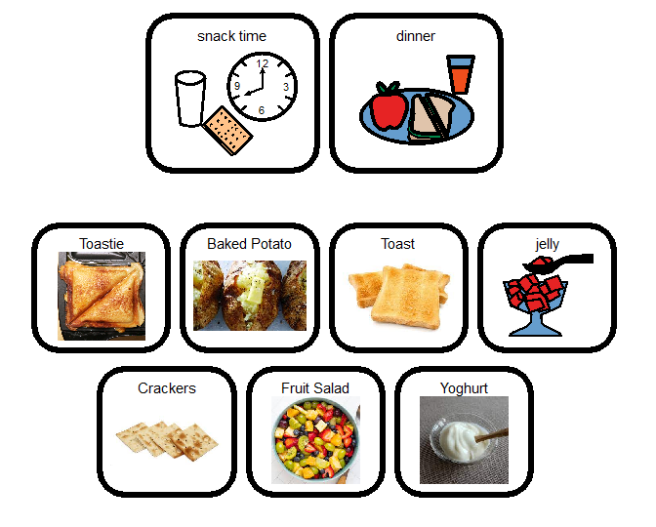favourite foods from home.**

**There are different rooms at the holiday club that I can explore.**

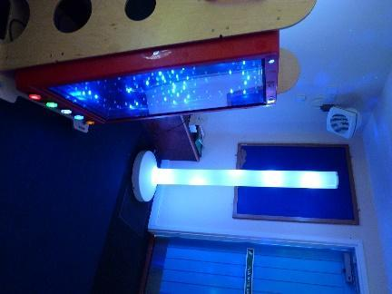

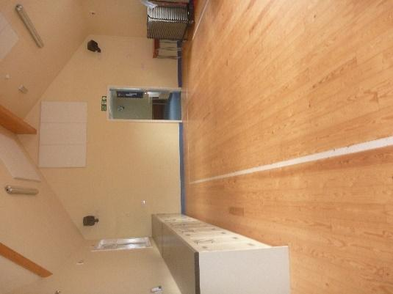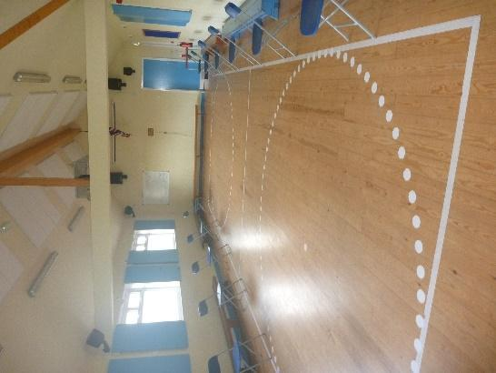

**The staff and other young people at the club are looking forward to meeting 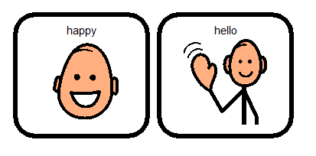me soon!**