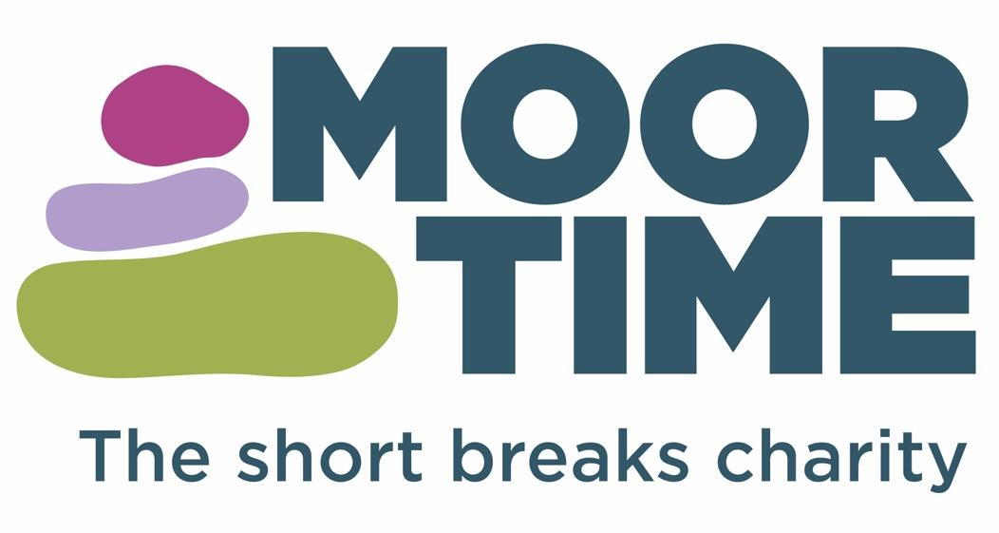

**MOOR TIME SOCIAL STORY**

**Saturday sessions at**

**Beechcliffe School**

Please share this social story with your young person to help them prepare for our Saturday sessions at Beechcliffe School.

**I am going to Saturday club.**

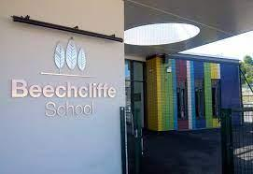

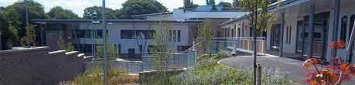

**I will do lots of fun activities. I can choose what I would like to do. I will have lots of fun**

**There is always an adult at Moor Time to help me if I am worried, or if I need some extra help. The adults are kind, and like to join in with all the fun activities.**

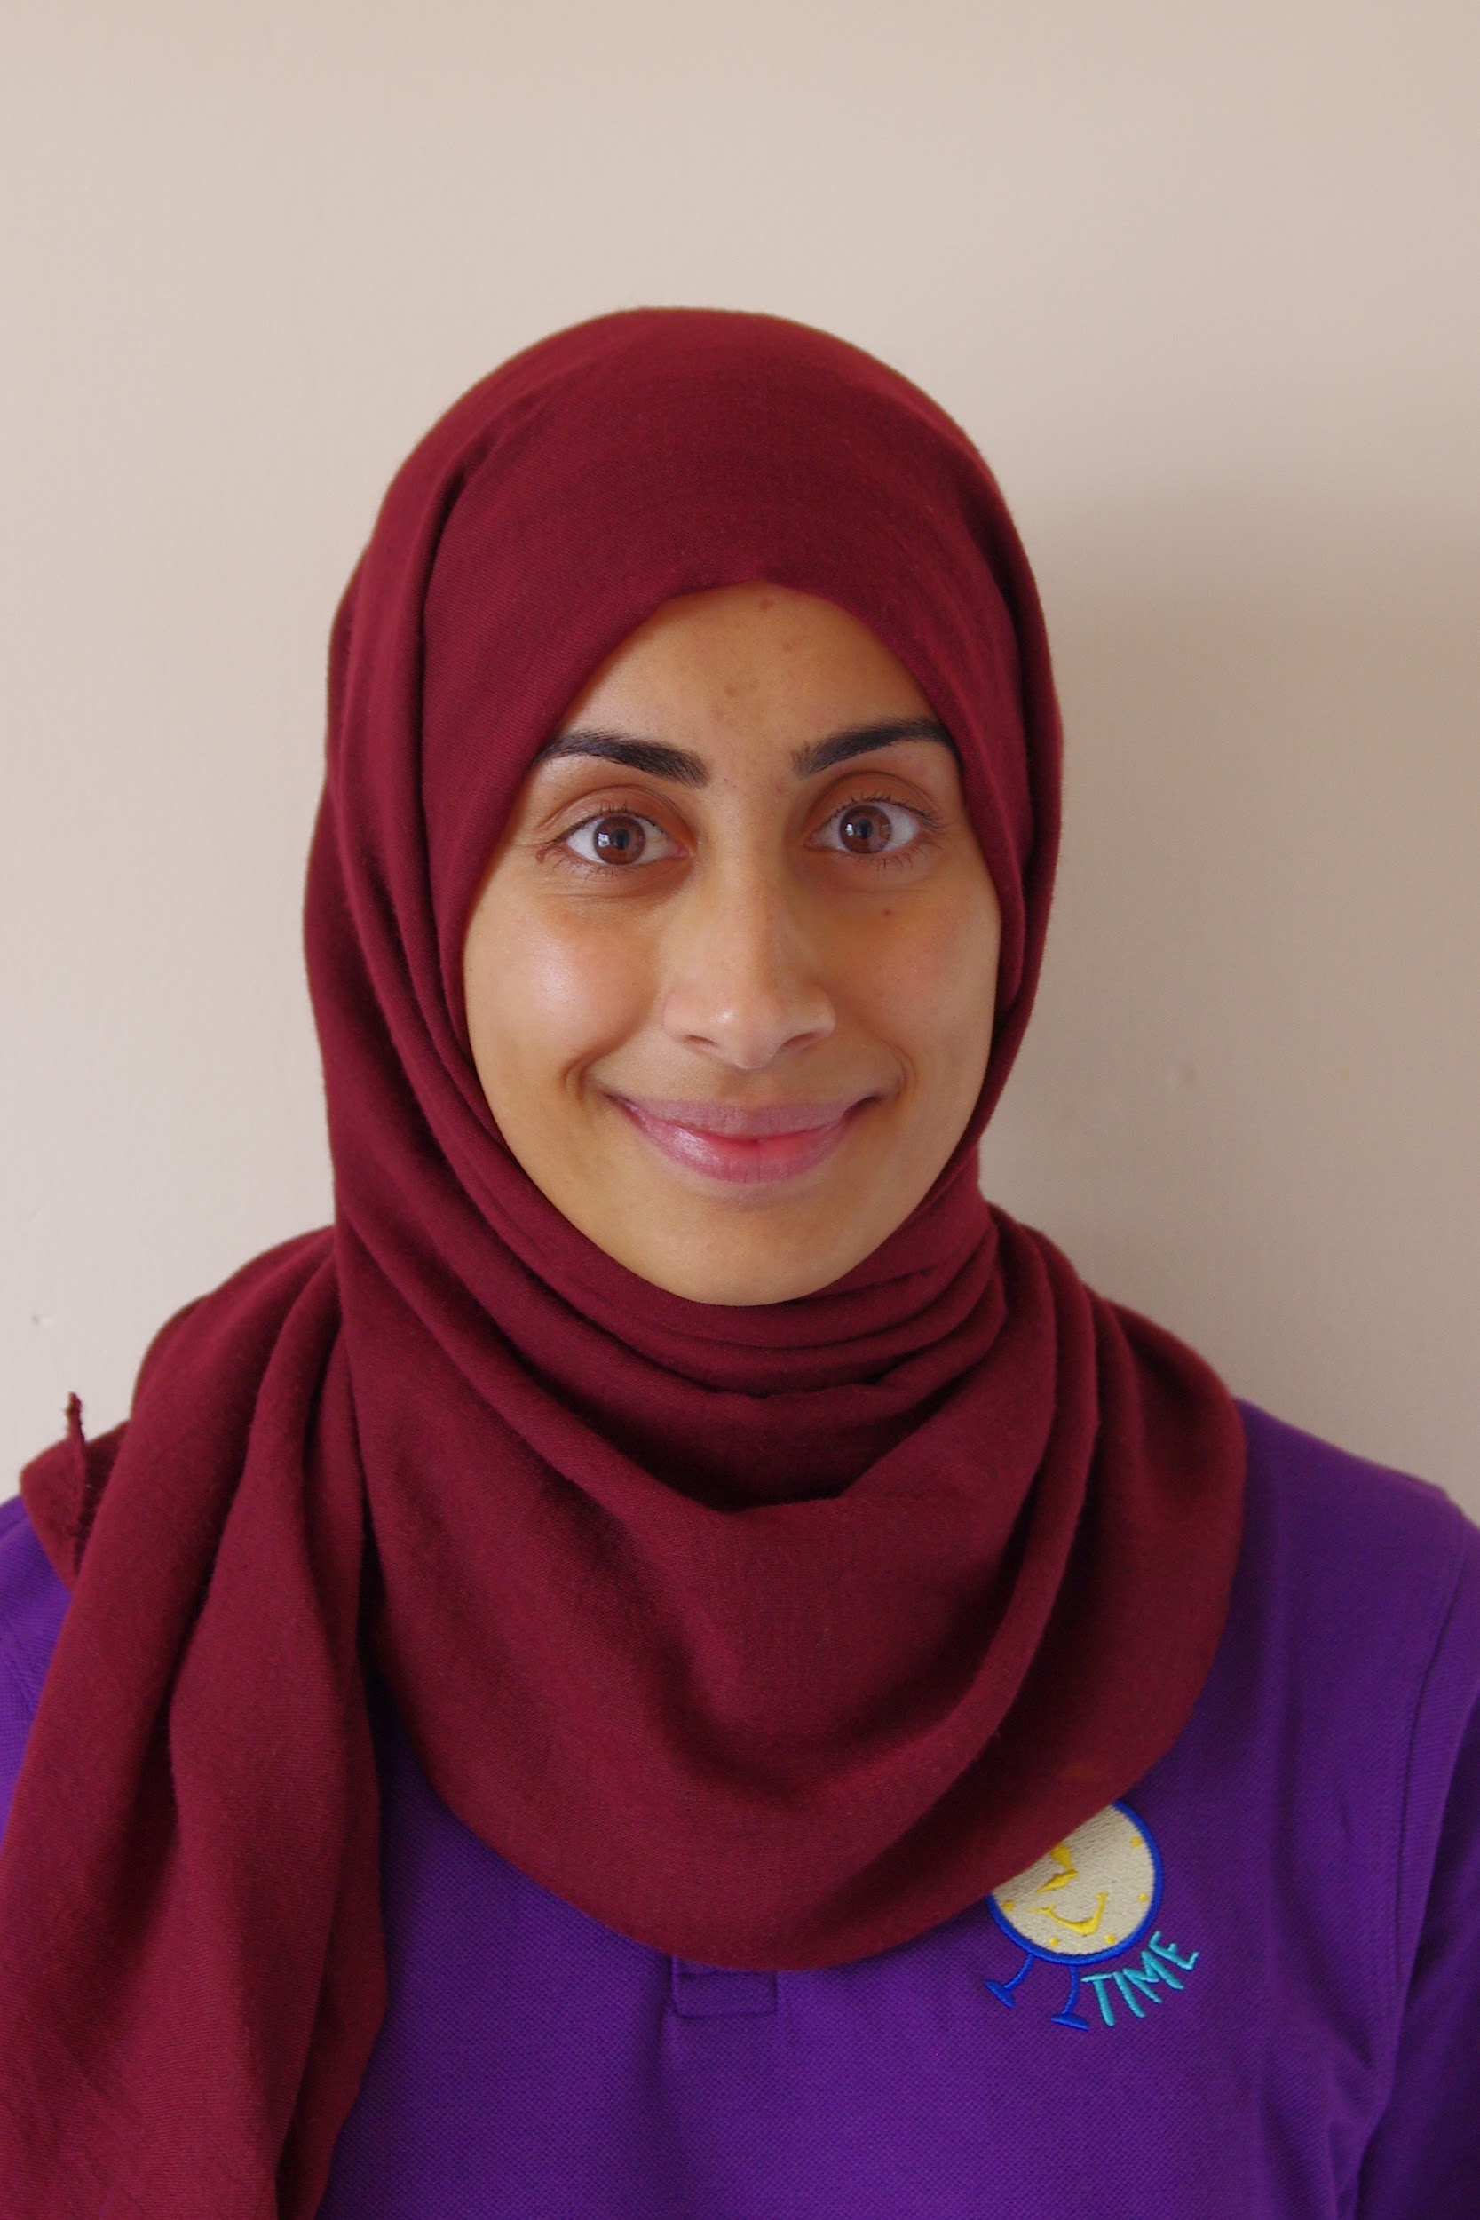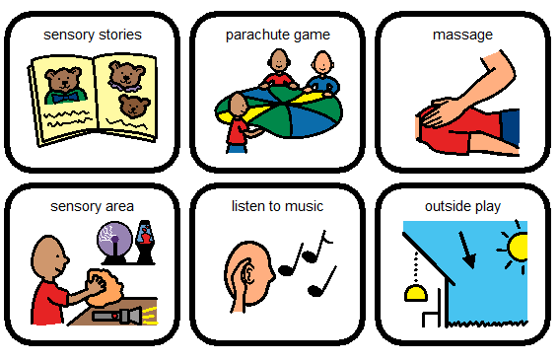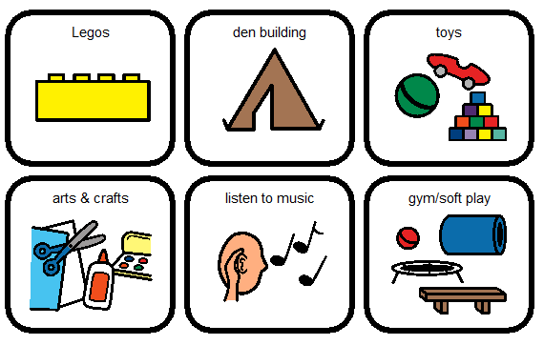

**I will have snack at the holiday club. I will bring my own favourite foods from home for dinner.**

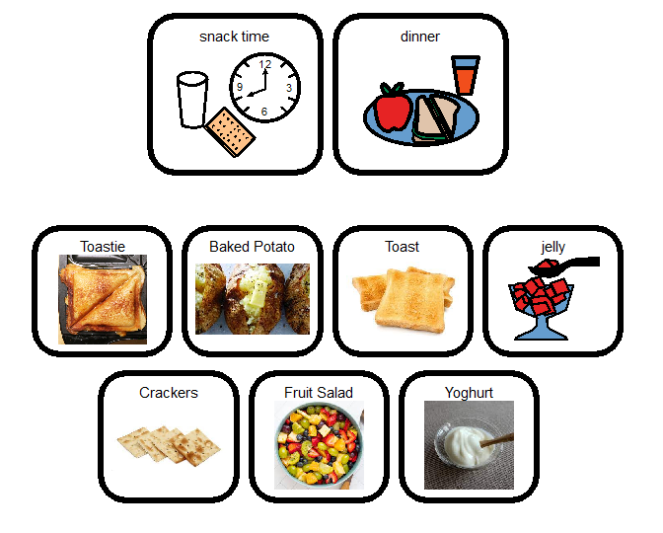

**There are different areas at Saturday club that I can explore and do activities in.**

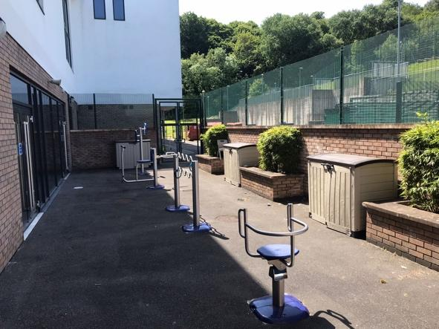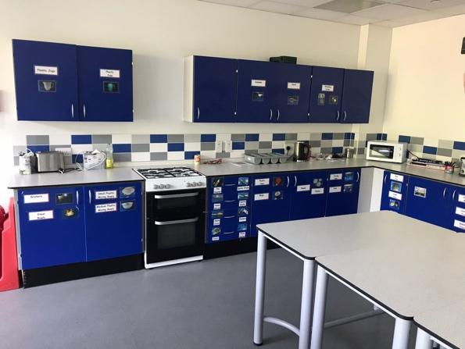

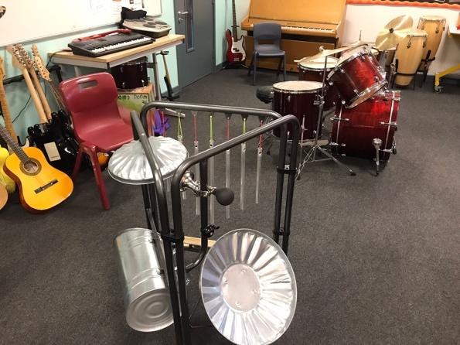

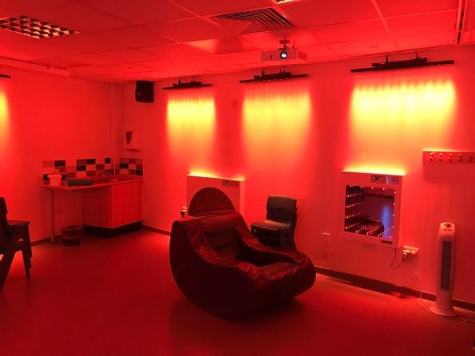

**The staff and other young people at the club are looking forward to meeting me soon!**



